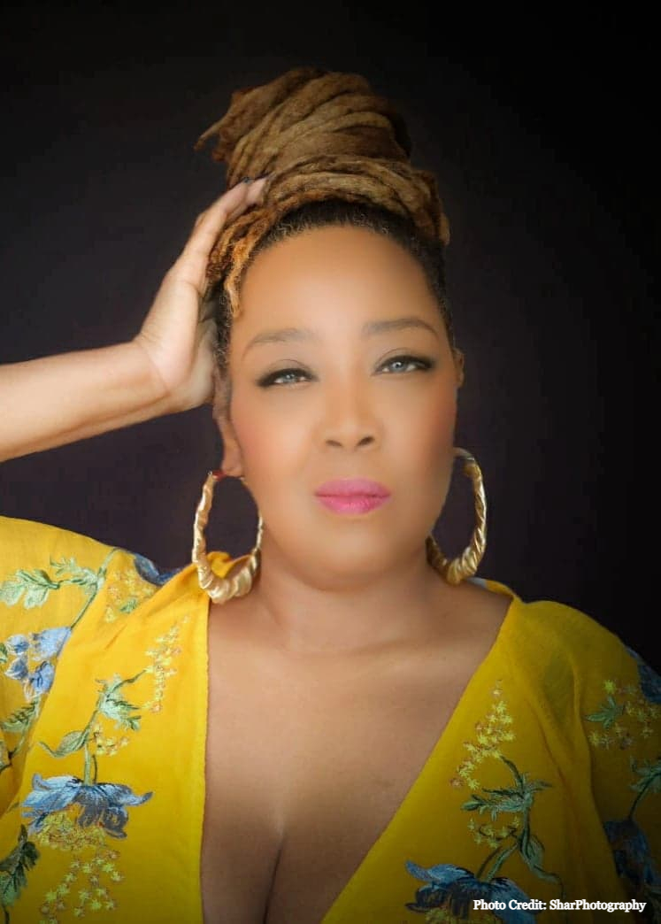Sugar Queen Biography

**Michele Denise, known as Sugar Queen, is a versatile American vocalist and songwriter, who performs blues in Europe, US, Asia and is currently based in the Netherlands.**

Her family roots are in northern Florida and Alabama which developed her affinity with gospel and blues. In her early years, Michele played classical piano and received a university scholarship. Never straying from her blues and gospel roots, she continued to perform in the Southern USA. Whilst touring various parts of the United States, she was singled out to perform in a historic “Mandela Released” event. During her time in the US, Michele worked a dual role as director/vocalist for several gospel and classic choirs.

Relocating to Asia in 2006, Michele formed in Malaysia the blues and classic rock band Deuces Wild.  During 2007 while performing blues, she also worked as a jazz singer with internationalist jazz pianist, Yiang Yi Sock in Malaysia. In 2008, Michele had the distinction of performing for King Tuan Yang Terutama in Malaysia. Michele worked as a session vocalist and recorded with blues/rock artist, Wang Wei (Rock Rhino) on his self-titled CD “Wang Wei” in Beijing along with Chen Yuli, as the audio engineer, who was the head of music production for the Opening Ceremony of the 2008 Beijing Olympics.

**A Must See Performer**

Sugar Queen’s smoldering vocal styling and charismatic stage presence captivates her audience. She tells her stories of southern life with gritty raw emotion. Sugar Queen broke on the European Blues music stages in 2017and has performed at a large number of major festivals, theaters and clubs. Sugar Queen has opened for such artists as Keb’ Mo’and continues her wildly successful European tours. Anyone who has seen blues and jazz singer Sugar Queen perform live on stage in recent years will undoubtedly have left the venue or festival tent with the sensation of having attended a memorable and overwhelming concert. For a moment, you were accompanied by the echo of her soulful voice, which sometimes reminds you of Mavis Staples. Whether singing a fast-paced foot stomper or slow burning blues, Sugar Queen brings the crowd to a big blues party!

**Album Success**

Sugar Queen has released 3 self written albums which have gained international recognition in the blues charts! Sugar Queen released  her third eagerly-anticipated in 2021 named “Better Days”.  It is an originally written personal narrative which explores Sugar Queen’s African-American roots. With her unique Chicago blues style, Sugar  Queen sings this rich history with an edge of gospel and soul.

**2018 Sugar Queen’s debut CD *“340 Blues”* ranked #9 in the RMR Top Chicago Blues Album**

**2019 *“Sugar Queen LIVE”* ranked #10 in the RMR Top Chicago Blues Album**

**2020 *“Sugar Queen LIVE”* ranked Top 25 in the RMR Top Chicago Blues Album**

**2021 *“Better Days”* ranked #4 in the RMR Top Chicago Blues Album**

**​   2022 *"Better Days"*  ranked #8 in the RMR Top Chicago Blues Album**